**Model Development Phase Template**

|  |  |
| --- | --- |
| Date | 10 July 2024 |
| Team ID | 739835 |
| Project Title | Credit card approval prediction by using ML |
| Maximum Marks | 4 Marks |

**Initial Model Training Code, Model Validation and Evaluation Report**

The initial model training code will be showcased in the future through a screenshot. The model validation and evaluation report will include classification reports, accuracy, and confusion matrices for multiple models, presented through respective screenshots.

**Initial Model Training Code:**

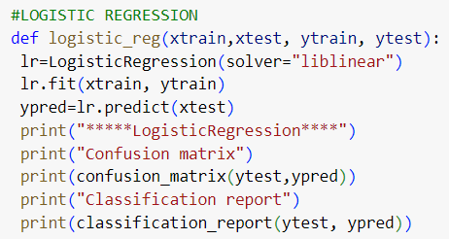

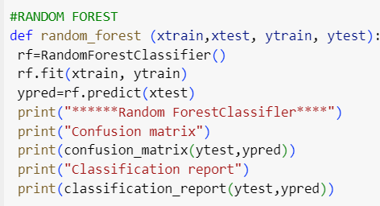

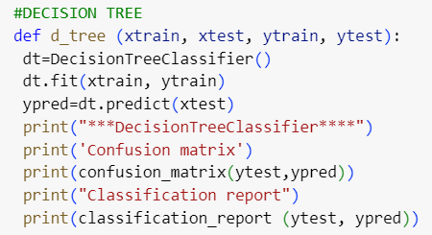

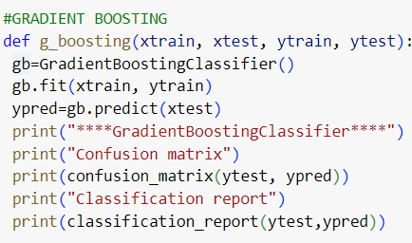

|  |  |  |  |
| --- | --- | --- | --- |
| **Model** | **Classification Report** | **F1**  **Scor e** | **Confusion Matrix** |
| Random  Forest |  | 81% |  |

**Model Validation and Evaluation Report:**

|  |  |  |  |
| --- | --- | --- | --- |
| Decision  Tree |  | 79% |  |
| Logistic Regression |  | 64% |  |
| Gradient  Boosting |  | 78% |  |